**Tadpoles**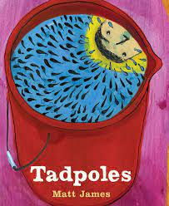

**By**

**Matt James**

**Science Posters**

## Matt James is the illustrator of Tadpoles as well as the author. He uses a variety of materials (acrylic paint, gouache, ink and cut paper) to create the pictures in his book, making them both interesting and compelling. Could you make a poster using any of these materials or 2 or more of them together?

## **Task:** Create a poster for your school or home that shows The Life Cycle of a Frog **or** An Ephemeral Pond**.**

## **Frog Poster**

### Teach someone about the life cycle of the frog

### Make sure that you use a circle to indicate a cycle

### Use the Title: Life Cycle of A Frog

### Label your diagrams at each stage (subheadings)

### Make it big enough so that people can see it

### Use interesting materials to illustrate your poster

### Add any interesting facts you learned from the book

### Make sure you add that your information came the book, Tadpoles by Matt James

### 

### 

### **Ephemeral Pond Poster**

### Teach someone what an Ephemeral Pond is (add a definition to your poster) and what creatures call it their habitat

### Use animals like Fairy Shrimp, Spotted Salamander, Twelve-Spotted Dragonfly, Spotted Turtle

### research a few facts about each species to put on your poster

### Use the Title: An Ephemeral Pond

### Label your diagrams (subheadings)

### Make it big enough so that people can see it

### Use interesting materials to illustrate your poster

### Add any interesting facts you learned from the book

### Make sure you add that your information came the book, Tadpoles by Matt James

### 

## 

