**Tadpoles**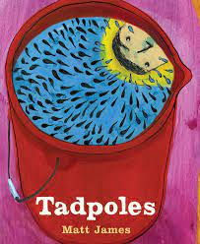

**By**

Matt James

Reading Questions

### What are some of the fun things that the dad and the son like to do together? Do they like spending time together? Do you do any of these things with your family?

### Does the boy in the book have a good imagination? Is he curious? How do you know? Are you curious about things, do you have a good imagination? Is it important to be curious and have a good imagination?

### The setting of this book is a rainy day. Rainy days provide lots of opportunities to explore things that only happen in the rain. Do you like rainy days? What would you like to do in this book? (stare at the clouds, play in a silo, listen to a chorus of frogs sing…) Why?

### What does the author, Matt James, mean when he writes, “When it rains, most creatures will head for cover?” Do the boy and his father live by this rule? Do you?

### Does the boy live with his mom and dad? How do you know? Was the boy sad about this at first? How do you think he feels now? Can you empathise with the boy and his situation?

### Did you notice the last page? Why do you think the author introduces the mom on the last page? What is he telling you about this family?

## 

