**Tadpoles**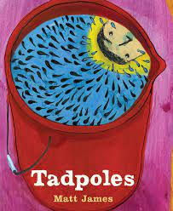

**By**

**Matt James**

### 

### 

## **Matt James gives us lots of interesting scientific information in this book, see if you can fill in the missing words in the following sentences:**

## In springtime, huge clouds bring ________. These clouds are called ________ clouds. There are many different kinds of ________.

## ________ like the rain. It makes them _______. When a group of frogs sing together it is called a _________.

## Puddles form in the field and they grow and grow until they become one _________ puddle. Then the field isn’t a ________ anymore. My dad says that puddles like these are called __________ ponds. That means that they won’t last for very_________.

## Frogs eggs are called __________. A single frog can lay __________ of eggs at a time. When the eggs hatch, _________ are born. Tadpoles start out as little black _____, and then they will grow gills and ______, starting with the _______ ones. When tadpoles grow legs, they are called _________.

### 

## 