Yellow Cedar Activity: 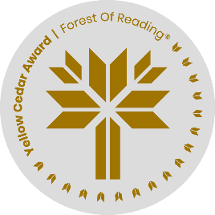Art Activity

*Animal Eyes* by Francoise Vulpė

Name: ______________________________

1. Throughout the book there are images of several different types of eyes. Choose your favourite images of eyes and draw them in the space below.

2. Imagine a new species is discovered in the world, deep in the ocean, high on a mountain, or isolated in a jungle. What type of species is it? What would its eyes look like? Draw a diagram of the species with a close up of its eye in the space below.