Yellow Cedar Activity: Discussion Questions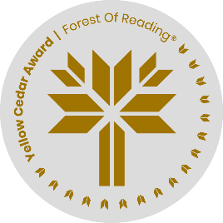

*Animal Eyes* by Francoise Vulpė

Name: ______________________________

1. How did the development of the camera eye help animals see better?

2. How does the human eye see things?

3. Why is it that most spiders, in spite of having many eyes, don’t have good vision?

4. What determines the colours that we see?

5. What does it mean to have trichromatic vision?

6. What differences are there between the fields of vision of predators and prey?

7. How do lobsters see in the dark at the bottom of the ocean?

8. Why are the pupils of cuttlefish often in a “W” shape?

9. Why are eagle eyes so good?

10. How do caribou detect predators in the snow?