**Name __________________________________**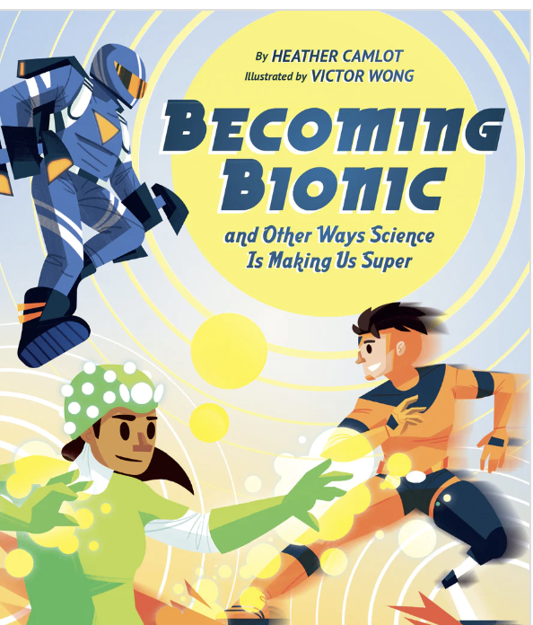

**BECOMING BIONIC**

Word Search

| C | Y | B | E | R | N | E | T | I | C | S | W |
| --- | --- | --- | --- | --- | --- | --- | --- | --- | --- | --- | --- |
| H | Y | P | N | O | T | H | E | R | A | P | Y |
| A | D | R | H | H | O | V | B | E | R | A | B |
| T | T | E | L | E | K | I | N | E | S | I | S |
| B | R | G | C | O | V | E | R | E | R | A | Y |
| O | A | E | R | O | D | Y | N | A | M | I | C |
| T | Y | N | T | E | L | E | P | A | T | H | Y |
| E | E | E | I | X | R | Y | J | P | O | L | I |
| C | P | R | O | S | T | H | E | S | I | S | N |
| H | I | A | X | B | O | B | T | F | O | H | F |
| N | M | T | R | R | C | G | P | P | C | O | A |
| O | P | E | A | E | R | E | A | O | R | V | R |
| L | L |  | Y | G | Y | N | C | L | I | E | E |
| O | A | G | A | I | N | T | K | Y | C | R | D |
| G | N | J | E | T | O | Z | Q | M | S | B | T |
| Y | T | W | G | E | N | O | M | E | K | O | E |
| G | S | T | C | S | I | J | L | R | V | A | C |
| B | I | O | N | I | C | O | P | L | L | R | C |
| A | E | M | G | Y | S | A | P | G | A | D | T |

Bionic Words

regenerate prosthesIs telekinesis cryonics aerodynamic chatbot genome xray

jetpack cybernetics hypnotherapy polymer infared technology implants bionic hoverboard electrodes AI telepathy