Design a Chocolate Bar
Design a chocolate bar wrapper and describe it. Which friend will you give it to and why?
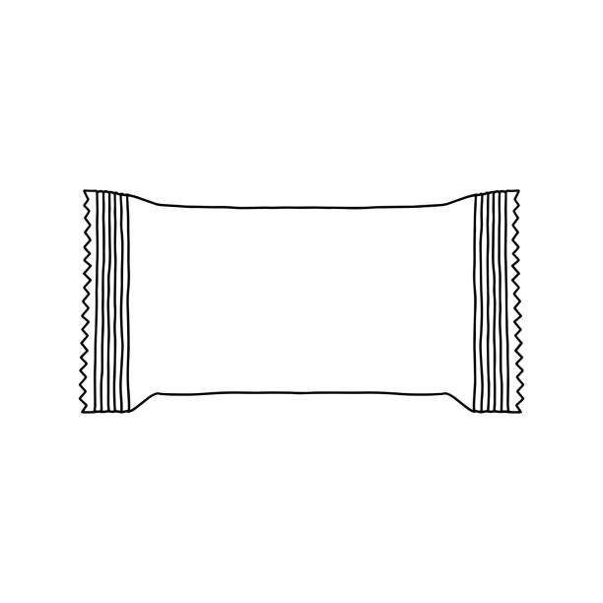 | Descriptive Words:  - Smooth  - Creamy  - Sweet  - Bitter-sweet  - Crunchy  - Nutty  - Marshmellow  - Crispy  - Fruity  - Buttery  - Salty  - Caramel  - Soft  - Firm  - Floral  - Fluffy

