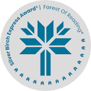

**Be The Designer You Were Born To Be**

**Salma Writes A Book By Danny Ramadan**

Salma’s on a journey to create a piece of literature that can help her conquer a big question: What does it take to be the best older sibling?

Consider a topic you’re currently interested in and create cover art that appeals to readers that have the same interest. It could be a cover art for any medium. Get cut out pictures, markers, colours, and whatever else you need to make the most alluring cover art below!

