
Word Search:
The Journal of Anxious Izzy Parker
by Alma Fullerton & illustrated by Beena Mistry

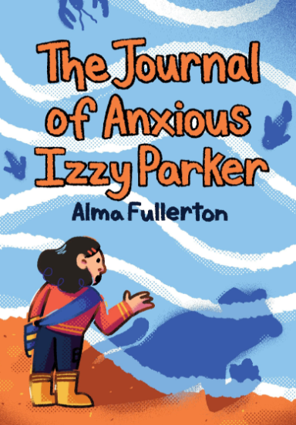
Draw a line through the 33 words from
The Journal of Anxious Izzy Parker
hidden in this Word Search.

Can you find them all?
Words can go forwards, backwards, or diagonally and are on a separate page if needed.

L | R | E | E | K | D | P | M | B | I | U | Y | G | T | P
P | A | H | N | E | U | A | S | R | T | M | A | N | E | U
B | Y | N | R | O | G | T | A | E | R | E | D | I | A | R
R | L | A | R | I | Z | M | C | A | O | M | H | Y | C | S
P | C | G | C | U | R | Y | R | T | F | O | T | R | H | E
S | R | A | L | G | O | D | A | H | M | T | R | R | E | A
L | L | O | L | L | C | J | S | E | O | I | I | O | R | G
L | J | I | V | C | T | R | U | O | C | O | B | W | N | U
O | O | E | R | I | Y | T | E | I | X | N | A | I | M | L
N | C | A | S | D | N | W | A | V | E | S | K | B | I | L
V | F | E | D | U | S | C | H | O | O | L | Z | O | F | S
T | C | U | A | G | O | R | E | T | A | D | Y | A | L | P
Y | B | B | O | N | S | M | J | T | E | I | K | N | U | B
C | R | Y | N | I | C | K | N | A | M | E | I | X | E | V
R | E | A | D | I | N | G | B | A | C | K | W | A | R | D
The Journal of Anxious Izzy Parker
Word Search words:

ANXIETY
BREATHE
COMFORT
CRY
GROUP
MAGICAL
OCEAN
PURSE
SCARED
SNOBBY
WAVES

BACKWARD
BUDDY
COURT
DOG
JOURNAL
MOUSE
PLAYDATE
READING
SCHOOL
TALKING
WORRYING

BIRTHDAY
BUNKIE
CRAFT
EMOTIONS
LION
NICKNAME
PROVINCE
SARCASM
SEAGULLS
TEACHER
ZONE

