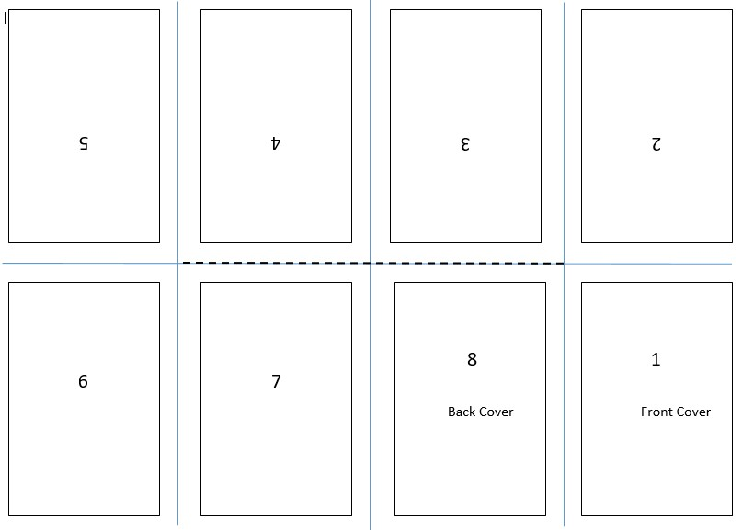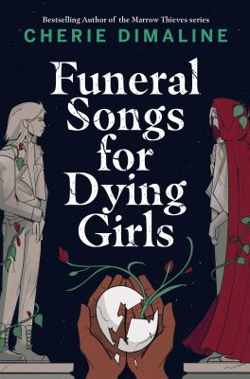

A zine is a self-published magazine, and it can be about any subject.

Create an 8-page mini-zine about Funeral Songs for Dying Girls. Choose a theme or a scene from the book. Use images and/or words. All you need is an 8.5”x11” blank sheet of paper.

1. Start with 8.5” x 11” piece of paper. Fold your sheet of paper in half lengthwise, and then fold it in half width-wise.
2. Then fold it again width wise so that now you have folded it into quarters.
3. Open the paper – it should have 8 sections.
4. Fold your paper in half width-wise, and then cut halfway across the middle from the fold.
5. Open you paper, and then fold it lengthwise (along the crease with the slit).
6. Hold the paper at either end, the push the ends in toward each other. The sections will fold to create an 8-page booklet.

Follow the template below: fold the paper, and then cut along the dotted lines only.

For more information about zines, check out fromatozine.com – the image below is from that website.

**Funeral Songs for Dying Girls**

**Make a Zine**