Into the Bright Open
Word Search

accident  fifteen  uncle | garden  secrets  attic | orphan  medicine  letters | Georgian Bay  Toronto  aunt | play  love  grief

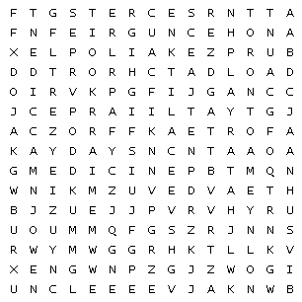

Into the Bright Open
Word Search – Answers

accident  fifteen  uncle | garden  secrets  attic | orphan  medicine  letters | Georgian Bay  Toronto  aunt | play  love  grief

