MALL GOTH
Time Capsule

Name: Date:

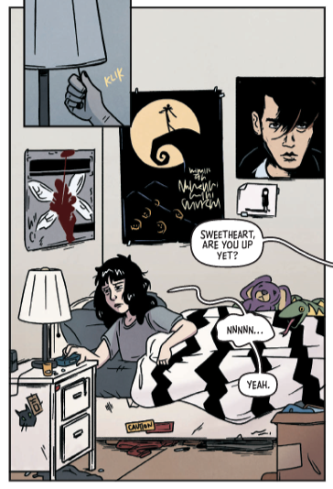
Set in 2003, Mall Goth will create deep feelings of nostalgia for anyone who lived through these years. As an example, on page 7 of their graphic novel, Kate Leth offers us a glimpse into Liv’s bedroom with a panel that offers an evocative glimpse into a teenager’s life at this time. From the posters on the wall to the bedding to the stickers on the nightstand, each of these things is recognizable and resonates powerfully.

Your task is to create a similar time capsule, but for future readers. For a person in 2043 reading a story about life today, what are the things you’d put into a time capsule to make them feel nostalgia for the current era?

You can sketch ideas in the space below, or use the chart on the back of this page to write out and explore some of your ideas.
MALL GOTH
Time Capsule

Item (and description) | Why is it powerful? What does it represent for you?

Kate Leth is a Canadian author and illustrator working in comics, animation, design, and feelings. A grown-up goth and pop culture devotee, Kate specializes in work for kids and teens. Their comics work includes Patsy Walker, A.K.A. Hellcat!; Girl Over Paris; Spell on Wheels; and Adventure Time, among others.
References
“Kate Leth.” Simon & Schuster, www.simonandschuster.com/authors/Kate-Leth/463756658.
Leth, Kate. Mall Goth. Simon and Schuster, 2023.

