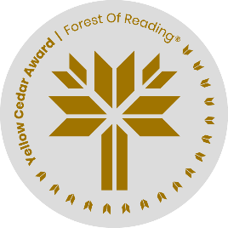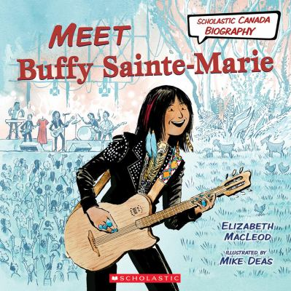

Scholastic Discussion Guide

<https://www.scholastic.ca/kids/discussionguides/pdfs/DG_ScholCanBio_Buffy_SainteMarie.pdf>

Buffy Sainte-Marie’s Official Website

<https://buffysainte-marie.com/>

Mike Deas’ (Illustrator) Official Website

<http://deasillustration.com/blog/>

**Meet Buffy Sainte-Marie**

**Additional Resources**