Word Search:

**Mehndi Boy**

by Zain Bandali & illustrated by Jani Balakumar

Draw a line through the 21 words from

**Mehndi Boy** hidden in this Word Search.

Can you find them all?

Words can go forwards, backwards, or diagonally and are on a separate page if needed.

|  |  |  |  |  |  |  |  |  |  |  |  |  |  |  |  |  |  |
| --- | --- | --- | --- | --- | --- | --- | --- | --- | --- | --- | --- | --- | --- | --- | --- | --- | --- |
| C | G | D | M | C | C | B | F | F | O | B | X | E | P | D | G | N | B |
| S | L | T | A | P | H | G | A | R | A | R | L | K | A | E | S | R | F |
| K | I | D | N | Z | E | I | R | C | I | M | H | I | P | C | H | T | P |
| E | T | T | D | S | Z | T | C | O | K | D | O | W | E | O | E | Y | S |
| T | T | O | A | H | D | L | A | K | A | P | G | U | R | R | R | P | O |
| C | E | P | Z | A | O | G | I | L | A | N | A | E | S | A | W | A | T |
| H | R | I | I | R | T | P | W | N | S | D | E | C | J | T | A | I | D |
| B | I | W | Y | I | S | M | U | D | G | E | E | D | K | I | N | S | V |
| O | N | F | I | N | G | E | R | T | I | P | S | E | Y | O | I | L | D |
| O | G | B | K | G | D | F | A | B | Y | W | S | T | S | N | K | E | A |
| K | C | S | P | L | E | N | D | I | D | X | O | P | Q | S | J | Y | Q |
| Z | J | Y | W | H | S | H | E | R | B | E | T | N | L | G | W | Z | J |

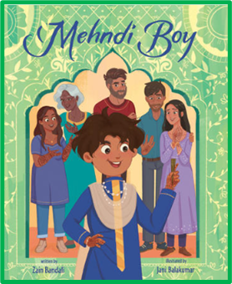**Mehndi Boy**

Word Search words:

BACKPACK

CHICKADEES

DAZZLING

DECORATIONS

DOT

FAMOUS

FINGERTIPS

FRIDGE

GLITTERING

GROANED

MANDAZI

PAISLEY

PAPER

PETALS

SHARING

SHERBET

SHERWANI

SKETCHBOOK

SMUDGE

SPLENDID

TOPI

