Name: ____________________________________
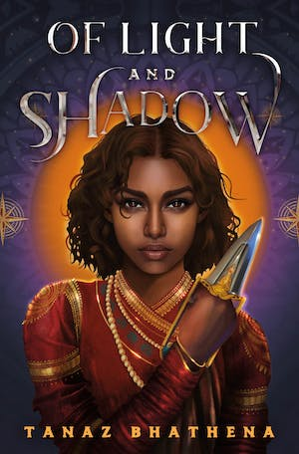
In a 17th-century India-inspired fantasy realm, Roshan Chaya, the leader of the impoverished Shadow Clan, seeks justice for her adoptive father's murder. Meanwhile, Prince Navin, second in line to the throne of Jwala, grapples with feeling like an outcast within his own family. During a night out, he's captured by the notorious Shadow Clan. While imprisoned, Navin befriends Roshan, and using his soul magic, he manages to escape. However, upon returning home, he finds that things are not the same. What he learned from the Shadow Clan has changed him, reshaping his view of the world. Amidst political tensions, corruption, and a growing attraction, both Roshan and Navin grapple with trust and the enduring power of love. Tanaz Bhathena's epic fantasy explores themes of justice, loyalty, and romance.

]

Discussion Questions
- Why does the Shadow Clan kidnap and hold Navin for ransom? What do they hope to achieve with this action? Do you believe their actions were justified?

- How does the Shadow Clan's motto, "When they don't give us our birthright, we steal it," reflect the central themes of the story and the motivations of the characters? What does this motto reveal about the group's values and their approach to achieving their goals? Are there any real-world historical or cultural parallels to this motto?

- Who is your favorite character in the story, and what qualities or traits make them stand out to you? How does this character's development or actions impact the overall narrative? Why do you find them relatable or compelling?

- What is Prince Navin's relationship like with Queen Bhairavi? How does their dynamic impact the plot and character development? What key moments or interactions highlight the complexities of their relationship?

- What motivates Prince Navin to align himself with the Shadow Clan in the story? Do the members of the Shadow Clan readily accept Prince Navin's assistance, or do they view him with suspicion? How does his presence affect the dynamics within the Clan? How does Navin's family react to his partnership with the Shadow Clan? Do they support his decision, or do they disapprove?

- How does the relationship between Roshan and Navin evolve throughout the story? What key events or experiences contribute to the development of their dynamic, and how do their interactions impact the plot? Do Roshan and Navin make an effective team in the story, or do they face challenges when working together? How do their individual strengths and weaknesses complement or clash with each other, and how does this affect their goals and the story's progression?

- Who are Roshan's biological family, and how does the revelation of her parentage impact her character? What internal struggles and external consequences does she face as a result of this revelation, and, in your opinion, was she ultimately better or worse off for knowing the truth? How does this revelation contribute to the broader themes and character development in the story?

- Discuss the ethical dilemmas and moral choices characters face in the novel. Are there any moments when characters are forced to make difficult decisions, and what do these choices reveal about their values and the themes of the story?
References
Bhathena, Tanaz. (2023). Of Light and Shadow. Macmillan Publishers.

