Simon Sort of Says
Word Search

alpacas  Nebraska  aliens  microwave | farming  science  funerals  friendship | peacock  telescope  SETI  treehouse | service  emus  Catholic  stars

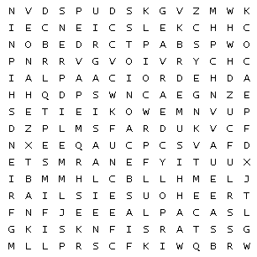

Simon Sort of Says
Word Search – Answers

