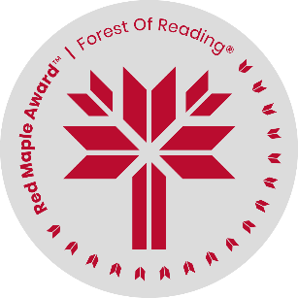
Red Maple Activity: Discussion Questions
The Druid’s Call by E.K. Johnston
Name: ______________________________

- Discuss what we learn about Doric from the flashbacks to her early life. What most worries her? What does she value?

- On her way to the Emerald Enclave, Doric meets Simon and helps his village repair their well. What does she learn about herself in taking on this task?

- What does Doric learn about being a druid when she first meets Palanus (p. 108-109)? Why is this knowledge important?

- Choose one of Doric’s friends – Torrieth, Liavaris, Jowenys, or Open – and discuss what they bring to the story, their strengths, and weaknesses.

- Were you surprised when Doric was so ready to Wild Shape? Why, or why not?

- Doric is often most fearful that people will be afraid of her. Describe what she learns about being powerful by the end of the book.

- Who are Doric’s most important teachers, and why?

- Doric deeply values the idea of finding, having, and being at home. Describe how her idea of home, especially Neverwinter Wood, changes throughout the book.

- The Druid’s Call is a prequel to Dungeons and Dragons: Honor Among Thieves. What do you think happens in the next story? If you know the story, describe what else you think might happen, and why.

- What do you think are the main messages of The Druid’s Call?

