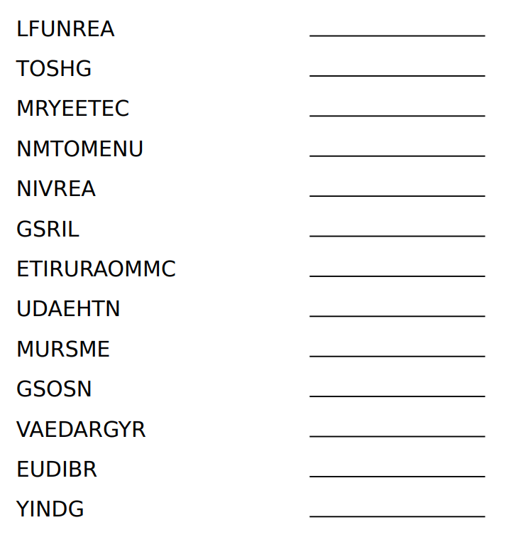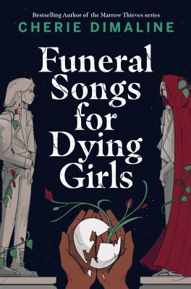

Unscramble the letters below to spell out words related to the story.

ANSWERS: FUNERAL, GHOST, CEMETERY, MONUMENT, RAVINE, GIRLS, CREMATORIUM, HAUNTED, SUMMER, SONGS, GRAVEYARD, BURIED, DYING

**Funeral Songs for Dying Girls**

**Word Scramble**