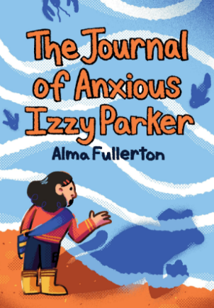
Crossword Puzzle:
The Journal of Anxious Izzy Parker
by Alma Fullerton & illustrated by Beena Mistry

The clues are on the next 2 pages.

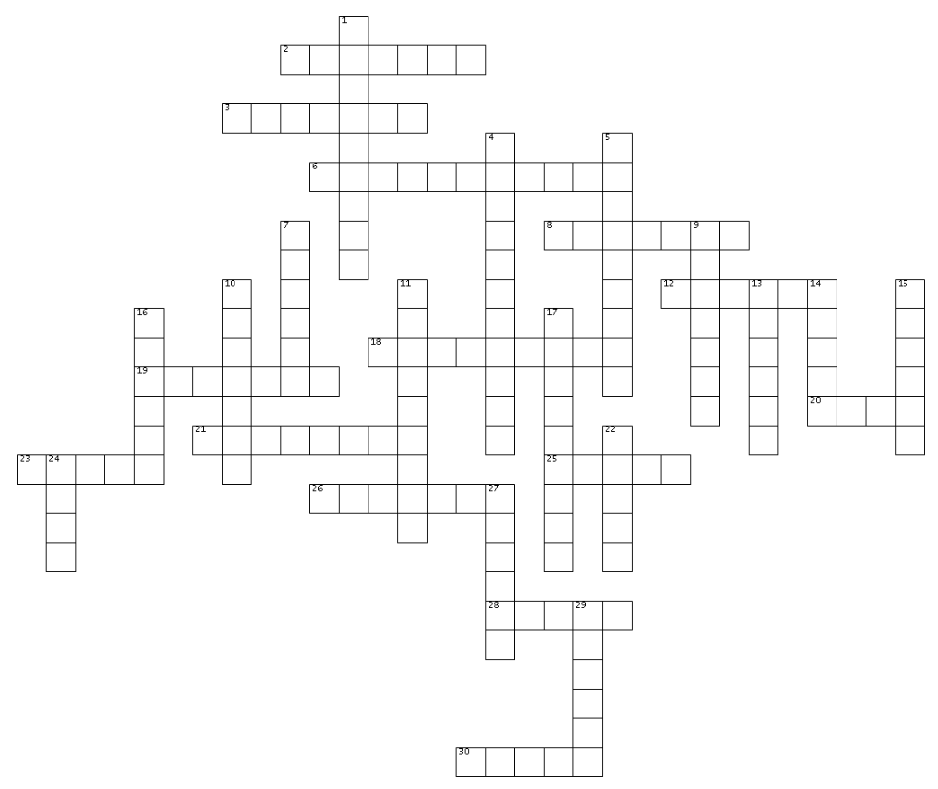

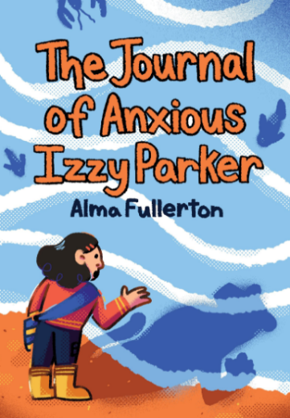
The Journal of Anxious Izzy Parker
ACROSS
2. Izzy has to write a daily ___ at school
3. Izzy made Jane this jewelry
6. Meemaw is Izzy’s Father’s ___
8. Izzy does not like ___ in front of other people
12. Jane is Izzy’s ___ in Toronto
18. Meemaw always has too many ___
19. Izzy’s favourite food is ___ fettuccine
20. Izzy and her Mom make ___ from goat’s milk
21. Izzy collects eggs in the ___
23. Sometimes Izzy would sit under the ___ in the playground.
25. Izzy and her Mom look for treasures on the ___
26. Izzy sometimes ___ that she said the wrong thing
28. ___ Mistry illustrated The Journal of Anxious Izzy Parker
30. Gandalf is Izzy’s new ___

DOWN clues are on the next page.



The Journal of Anxious Izzy Parker
DOWN

- Alma ___ is the author of The Journal of Anxious Izzy Parker
- Izzy is good at combining colors and understands ___
5. Izzy’s new house used to be a bed & ___
7. Izzy has her own craft ___.
9. Tests make Izzy ___.
10. Meanie is the name of Izzy’s ___
11. Izzy’s mother makes ___ pancakes & sausages
13. Izzy moved from Ontario to Prince ___ Island
14. At show-and-tell Dianna shows a turquoise ___
15. Izzy shares with Dianna that she doesn’t like being in ___
16. Izzy and her Mom sell things they make in an ___ store.
17. Izzy and her Mom go ___ riding on the beach.
22. Izzy and Gandalf turn out to be a perfect ___.
24. If she were an animal, Izzy would like to be a ___
27. Trinity misunderstands Izzy and thinks she is ___
29. When Izzy is anxious she counts to ___.

