MALL GOTH
Discussion Questions

Name: Date:

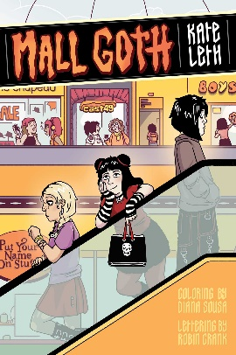
After reading Mall Goth by Kate Leth, seek out a small group of fellow readers to engage in a discussion of the graphic novel. In your talk, remember good discussion practices: allow for silence to let people process their thoughts, listen to your peers’ complete thoughts before you respond, and ask follow-up questions based on others’ responses to deepen and extend your group discussion.

Discussion Questions

Use the space below the questions to outline out some thoughts ahead of your discussion.

- Malls, for teenage Gen Xers and millennials (people born between 1965 and 1995), represented ‘third places’ where teens formed communities outside of home and work or school. With malls on the decline today, where are the ‘third places’ for you and your friends?

- Liv, despite facing many challenges in her life, draws on those around her to find strength and joy. Who are these people and how do they support her? What are your sources of strength and joy when times are difficult for you?

- Liv is initially hesitant to share that she is bisexual with the people she meets in her new school. What do they collectively do to ease Liv’s concerns? What should schools do to create inclusive and welcoming environments? What can people outside of the 2SLGBTQ+ community do to be a good allies?
MALL GOTH
Discussion Questions

- Video games are important in the lives of the teens in Mall Goth, with both PC gaming and old-school video arcades playing big roles. How do the experiences with video games for the characters in Mall Goth compare to yours?

- Many characters in Mall Goth defy expectations others have for them, some positively and others to their detriment. Who is the character in Mall Goth who most surprised you? What are your feelings about the expectations the people in your life have for you?

- Prior to Mall Goth, what experiences have you had reading graphic novels? What’s an example in this book where the text and images really complemented each other and enhanced your enjoyment of the story?

Kate Leth is a Canadian author and illustrator working in comics, animation, design, and feelings. A grown-up goth and pop culture devotee, Kate specializes in work for kids and teens. Their comics work includes Patsy Walker, A.K.A. Hellcat!; Girl Over Paris; Spell on Wheels; and Adventure Time, among others.
References
“Kate Leth.” Simon & Schuster, www.simonandschuster.com/authors/Kate-Leth/463756658.
Leth, Kate. Mall Goth. Simon and Schuster, 2023.

