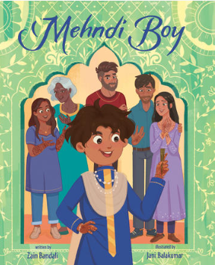
Crossword Puzzle ANSWERS:
Mehndi Boy by Zain Bandali
illustrated by Jani Balakumar

The clues are on the next 2 pages.

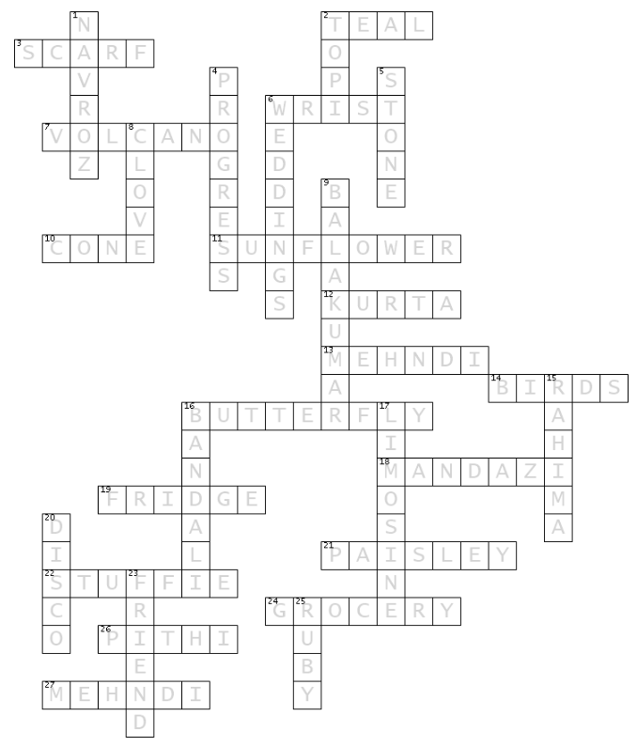
Mehndi Boy Crossword Clues:
ACROSS

2. Rahima wears a ___ ghagra choli.
3. One of Rahima’s bridesmaids gives Tehzeeba a ___.
6. Tehzeeb drew a mehndi design on his teacher’s ___.
7. Tehzeeb’s nervousness feels like a ___.
10. Henna is usually applied using a plastic ___
11. Tehzeeb created a ___ design on his Mom’s palm.
12. A loose fitting tunic worn by women and men.
13. Jenny Bai is the most famous ___ artist in town.
14. Chickadees are ___.
16.Tehzeeb drew a ___ design for the librarian.
18. African Doughnuts.
19. Ayaz Uncle put the card from Tehzeeb on the ___.
21. A tear-drop-shaped design.
22. Mr. Unicorn is Tehzeeb’s ___.
24. Tehzeeb’s Mom buys more mehndi cones at the Indian ___ store.
26. A pre-wedding ceremony.
27. Rahima asks Tehzeeb to do her ___.


DOWN clues are on the next page.

Mehndi Boy Crossword Clues:

DOWN
1. The first day of spring.
2. Hat in Kutchi.
4. Ayaz Uncle always says practice makes ___.
5. When Ayaz Uncle is mean, Tehzeeb’s heart feels like a ___.
6. Tehzeeb’s favourite celebrations are ___.
8. The henna Jenny uses smells like the spice of ___.
9. Jani ___ illustrated Mehndi Boy.
15. Tehzeeb’s cousin ___ is like his big sister.
16. Mehndi Boy’s author is Zain ___.
17. Tehzeeb got to ride in this type of car with Rahima.
20. The ceiling of the limo looked like a ___ ball.
23. Maya is Tehzeeb’s best ___.
25. Tehzeeb’s kurta glimmers like a ___ in the sun.

