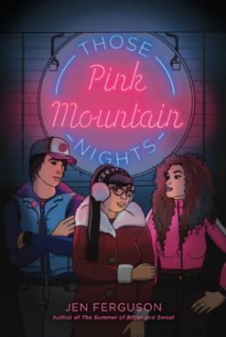
Those Pink Mountain Nights
Discussion questions

Name: ______________________________ Date: ______________________

- There are trigger warnings and comforting words by the author before the book starts. Have you found similar notes in other books? Have you ever thought after reading a book that there should have been?

- Why do you think Berlin is put in charge at Pink Mountain Pizza when Joe (the owner) is not there, even though Cam has been there longer?

- Cam says that he is haunted by the wapiti (elk) but Berlin says she dreams of the wapiti. What meaning do Cam and Berlin find in this?

- Berlin calls Cam “Cameron” until they find the wapiti. Why do you think she calls him “Cam” after that?

- Why is it important for communities to support small local businesses?

- How would the workers be affected by the sale of Pink Mountain Pizza to a big corporation like the Poseidon Group?

- Do you think Berlin did the right thing by posting on social media about the sale of PMP? Why or why not?

- How are Berlin’s social media posts seen as anti-black racism? How does getting the community involved affect Joe, the owner of PMP?

- Why do you think the police stopped looking for Kiki? Do you agree that more effort goes into looking for missing white people than BIPOC? Why?

- The chapters are titled by day and time such as “Friday Afternoon” and “Saturday, Very Early Morning”. Why do you think the author did this?

- What do you think of Quinta’s reason(s) for “breaking up” with best friend Berlin? Do you agree with what she did or how would you have handled the friendship?

- Do you think Berlin should forgive Quinta once she knows the reason(s) for the “break-up”? Why or why not?

- Do you identify with any of the characters in the book? Who and why – or why not?

- Come up with an idea for your own pizza special. What would be on it and what would you call it?

About the Author
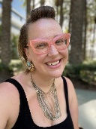
Jen Ferguson is Michif/Métis and white and has a PhD in English and creative writing.
Her debut novel, The Summer of Bitter and Sweet, received great acclaim. She lives in Cedar
Rapids, Iowa, and teaches at Coe College. She always puts pineapple on her pizza. Visit her
online at jenfergusonwrites.com.
Photo credit: Jen Ferguson

