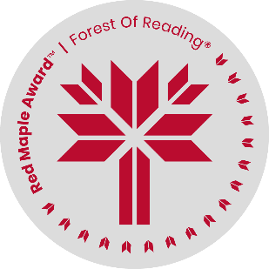
Red Maple Activity: Reading Response
The Druid’s Call by E.K. Johnston
Name: ______________________________

Starting on page 152 of The Druid’s Call, we find out more about the druids being able to take on Wild Shape – becoming animals. What animal would you want to become, and why? Write a short creative writing passage about what you think it would be like.

