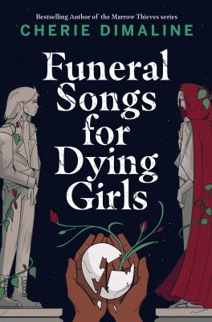

Working alone or in pairs, write and record a book trailer for Funeral Songs for Dying Girls.

Before you record it, plan it out. Write a description of the book, and being sure to include some quotes from the novel. You can also include quotes from reviews, and your own opinion. Add art and other images that represent the themes and story to the trailer. You want to capture the viewer’s attention and intrigue them so that the will want to read the book.

When your trailer is complete, share it with your class.

**Funeral Songs for Dying Girls**

**Book Trailer**