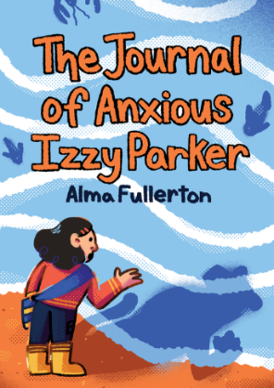
Fill in the missing words:

The _ _ _ _ _ _ _ of _ _ _ _ _ _ _ Izzy Parker

By _ _ _ _ Fullerton and illustrated by Beena
_ _ _ _ _ _

- It is hard for me to make new _ _ _ _ _ _ _.

- Friday I got up early and fed all the animals and collected
_ _ _ _.

3. Yesterday I made myself go to my _ _ _ _ _ _ _ group.

4. Dianna showed everyone the _ _ _ _ _ she made with her mother.

5. It would have been a great anxiety-free walk if Mom had not suggested I ask Dianna to come for a _ _ _ _ _ _ _ _.

Word choices:

Alma
reading
friends
journal
anxious
eggs
dress
Mistry
Playdate
lionlike

