MALL GOTH
Personal Expression

Name: Date:

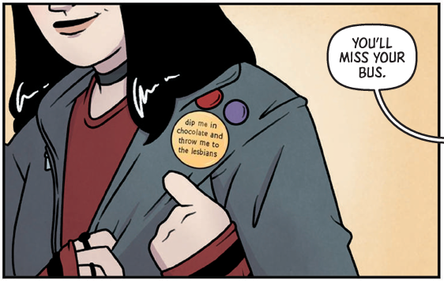
In Kate Leth’s Mall Goth, Liv uses buttons to help express her personality and identity to those around her. Though the graphic novel is set in 2003, this is a trend that has certainly survived, and has actually grown to include pins and the stickers we attach to our laptops and water bottles. In fact, Kate Leth runs an Etsy shop that sells all of these items.

Your task here is to design a pair of buttons or stickers that might help express your interests and the parts of your personality and identity that you’re happy to share with the world. In your designs think about how you might use colour, images, and text to convey your ideas.

Kate Leth is a Canadian author and illustrator working in comics, animation, design, and feelings. A grown-up goth and pop culture devotee, Kate specializes in work for kids and teens. Their comics work includes Patsy Walker, A.K.A. Hellcat!; Girl Over Paris; Spell on Wheels; and Adventure Time, among others.
References
“Kate Leth.” Simon & Schuster, www.simonandschuster.com/authors/Kate-Leth/463756658.
Leth, Kate. Mall Goth. Simon and Schuster, 2023.

