**Princess Pru and the Ogre on the Hill**

**Help Oggy find his way to the bakery!**

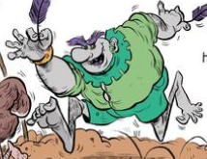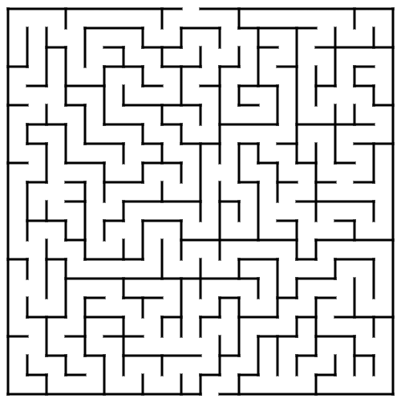

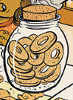

**Solution:**

