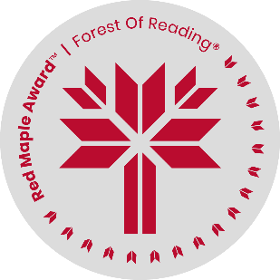
Red Maple Activity: Reading Response
Seekers of the Fox: A Thieves of Shadow Novel by Kevin Sands
Name: ______________________________

At the end of the novel, Lachlan has been saved and the group is finishing their adventure in the weavers’ enclave, but the Eye tells Callan their work isn’t done. What do you think happens to them after the events of the book? Share your thoughts in a short creative writing passage.

