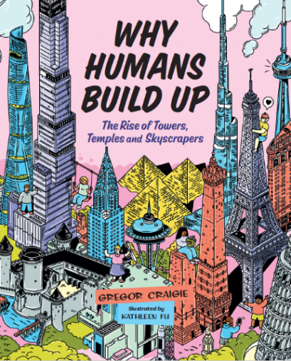

Name: _______________________

***WHY HUMANS BUILD UP***

Trivia

***Fill in the blank:***

1. The Tower of _____________ was the “super-skyscraper of its day”, built about 8300 BCE.
2. Pyramids were not built for people to live in, they were built as ________ for Egyptian kings or Pharaohs.
3. A many-tiered tower that is a sacred building erected by Buddhists is called a ___________.
4. Paris is the home of the famous ____________Tower, made of wrought iron.
5. The Leaning Tower of _________ was closed for 7 years in the 1990s because it was at risk of falling over. The ground beneath had to be stabilized and work done to restore the tilt to 3.97˚
6. List four of the eleven reasons (also chapter titles) the book gives to answer the question “Why humans build up”
7. ________________________
8. ________________________
9. ________________________
10. ________________________
11. The official/formal name of the tower known as Big Ben is___________________________.
12. The CN Tower opened in the year__________.
13. What are two benefits of having express elevators in tall buildings?
14. _______________________________________________________________________
15. _______________________________________________________________________
16. The building Taipei 101 has a giant steel ball called a ___________________________ to counteract the building’s side-to-side movements in strong wind.
17. Where is the Space Needle located (city & state)? __________________________________
18. India’s richest man built for himself, his family and employees a 27-floor building called ______________. This building includes a grand ballroom, a theatre and three heliports!
19. The Bahrain World Trade Center uses “Green Technologies” such as (name 2 of the 4):
20. _______________________________________
21. _______________________________________
22. Manitoba Hydro Place is a building that uses 70% ________ energy than similar sized buildings.

**Review the Glossary on pages 80-81 of the book to learn about terms used!**

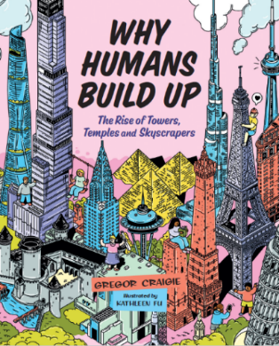

***WHY HUMANS BUILD UP***

Trivia

Answers

1. The Tower of (Jericho) was the “super-skyscraper of its day”, built about 8300 BCE. (pp.6-7)
2. Pyramids were not built for people to live in, they were built as (tombs) for Egyptian kings or Pharaohs. (p.14)
3. A many-tiered tower that is a sacred building erected by Buddhists is called a (pagoda). (p15)
4. Paris is the home of the famous (Eiffel) Tower, made of wrought iron (pp.26-27)
5. The Leaning Tower of (Pisa) was closed for 7 years in the 1990s because it was at risk of falling over (p.18)
6. List four of the eleven reasons (also chapter titles) the book gives to answer the question “Why do humans build up?” (Any 4 of these: 1. Security 2. Spirituality 3. Ingenuity 4. Utility 5. Rivalry 6. Beauty 7. Industry 8. Observatories 9. Luxury 10. Efficiency 11. Sustainability) (Table of Contents)
7. The official/formal name of the tower known as Big Ben is (The Elizabeth Tower) (p.30)
8. The CN Tower opened in the year (1976) (p.35)
9. The two benefits of having express elevators in tall buildings are
10. Reduces the number of elevators needed
11. Reduces the number of floors people will have to stop at on their way up or down
12. Taipei 101 has a giant steel ball called a (tuned mass damper) (p. 48)
13. The location of the Space Needle is (Seattle, Washington). (p.59)
14. India’s richest man built for himself, his family and employees a 27-floor building called (Antilia). (p.66)
15. The Bahrain World Trade Center uses “Green Technologies” such as (any 2 of these 4) (p.76):
16. Wind turbines
17. Seawater cooling
18. Shading measures
19. Deep gravel roofs for insulation
20. Manitoba Hydro Place is a building that uses 70% (less) energy than similar sized buildings. (p.77)