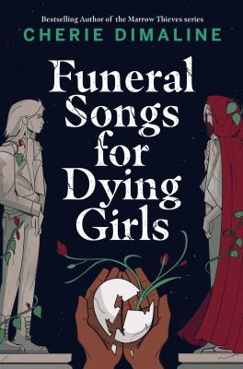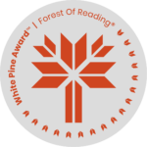

1. Did you enjoy Funeral Songs for Dying Girls? Have you read any similar stories? Have you read any of Cherie Dimaline’s other books?
2. In the story, Phil is a ghost who appears to Winifred. Winifred eventually falls in love with her. Do you believe in ghosts? Have you ever seen a ghost? Have you ever taken a ghost-walk tour? Do you think you could fall in love with a ghost?
3. Winifred and her father live in Cabbagetown, and both the Riverdale Zoo and the Bloor Viaduct are mentioned. Do you think having Toronto as the setting makes you feel more connected to the story? Would you set a story you wrote in your neighbourhood? If so, what landmarks would you include?
4. Winifred and her cousin Penny don’t get along very well. Do you have any suggestions on what they could do to understand each and have a better relationship? Have you been successful in strengthening a difficult relationship with a relative or friend?
5. What do you feel the author, Cherie Dimaline, was trying to say with this story?
6. At the end of the novel, Winifred and her father are leaving Toronto to head to the west coast. Did you like the ending? If not, what ending do you think would have been better?

**Funeral Songs for Dying Girls**

**Discussion Questions**