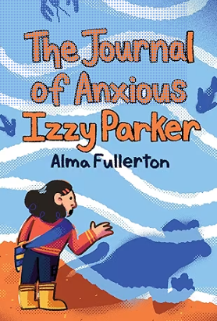

Be Kind to Izzy!

When I read Izzy’s journal I wanted to write to her and say “don’t worry, Izzy, people like you!”

Pick 1 of Izzy’s journal entries and write her a reply to help her not to worry. Be her friends!

Dear Izzy:

From your friend, ___________________________________________

