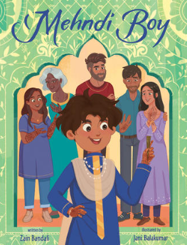
What does it look like?

In Mehndi Boy Tehzeeb loves his ruby-colored kurta and when he wears it he feels “handsome and confident”.

What is your FAVOURITE thing to wear?

Pick your favourite outfit and draw a picture of what it looks like. You could draw it like page 49 in the book with a mirror!

