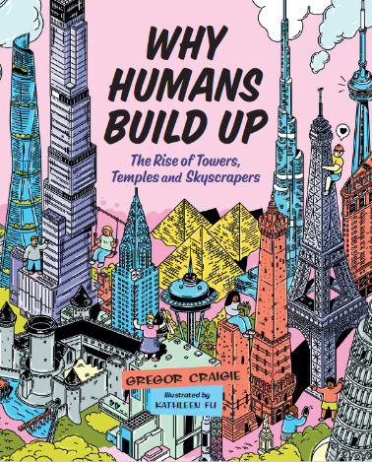***Why Humans Build Up***

Match-up game

***See if you can match up the name to the building!***

***Write the letter from the picture beside the name of the building***

1. Bahrain World Trade Center _____
2. 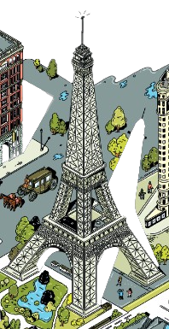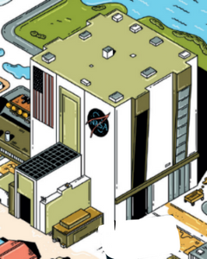Big Ben _____
3. Burj Khalifa _____

(A)

(B)

1. Chrysler Building _____
2. CN Tower _____
3. Eiffel Tower _____
4. Empire State Building _____
5. NASA Vehicle Assembly Building _____
6. Space Needle _____
7. 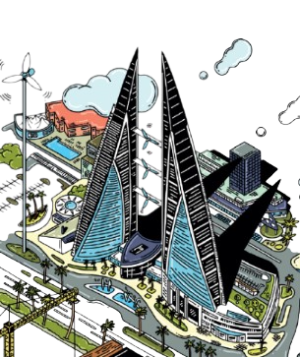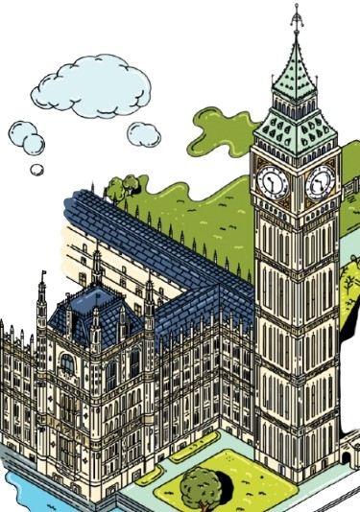Tokyo Skytree _____

(D)

(C)

*(Images of buildings are not to scale)*

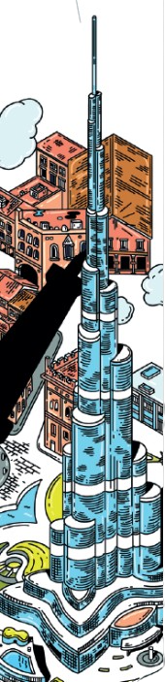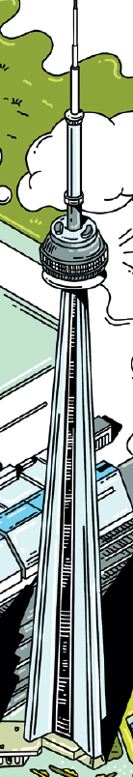

(F)

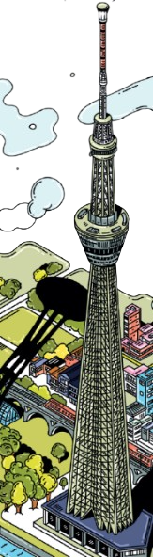

(G)

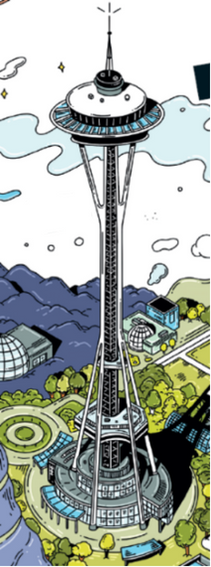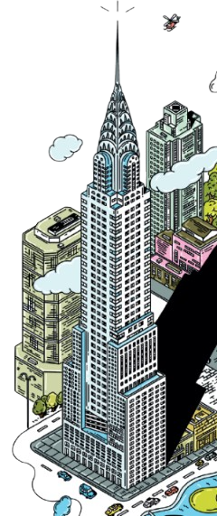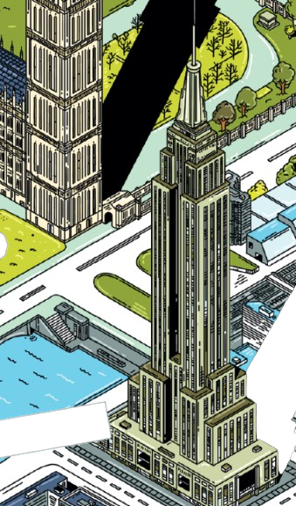

(J)

(I)

(H)

(E)

***Why Humans Build Up***

Match-up game

***Answers:***

1. Bahrain World Trade Center (C)
2. Big Ben (D)
3. Burj Khalifa (G)
4. Chrysler Building (I)
5. CN Tower (F)
6. Eiffel Tower (A)
7. Empire State Building (J)
8. NASA Vehicle Assembly Building (B)
9. Space Needle (H)
10. Tokyo Skytree (E)

Created by E.Coats with images by Kathleen Fu, illustrator of the book *Why Humans Build Up* by Gregor Craigie

Forest of Reading – Yellow Cedar Nominee