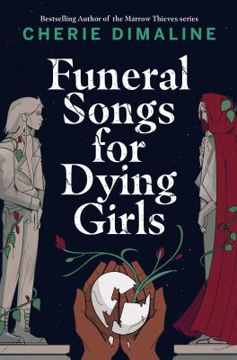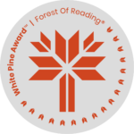

**Funeral Songs for Dying Girls**

**Additional Resources**

Tundra Books Educator’s Guide (Including Discussion Questions)

<https://tundrabooks.com/wp-content/uploads/2023/06/Funeral-Songs-for-Dying-Girls-Educators-Guide.pdf>

Cherie Dimaline’s Official Website

<https://www.cheriedimaline.com/who-i-am>

Toronto Star Profile of Cherie Dimaline

<https://www.thestar.com/entertainment/books/in-cherie-dimaline-s-latest-book-funeral-songs-for-dying-girls-a-young-woman-grapples/article_3ee20c52-e13f-5c90-86f0-d6b0f9ee5114.html>

Cherie Dimaline in Conversation at Vancover Writer’s Fest, October 2023 (introduction starts at 3 minutes, Cherie begins speaking at 6 minutes)

<https://www.youtube.com/watch?v=ZPlIrBWplCQ>

Interview with Cherie Dimaline on CBC’s Q

<https://www.cbc.ca/arts/q/cherie-dimaline-funeral-songs-for-dying-girls-q-tom-power-interview-1.6799935>