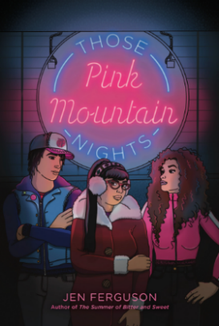
Those Pink Mountain Nights
Jen Ferguson

Jen Ferguson explores a number of important contemporary issues in Those Pink Mountain Nights. In this activity, you’ll have the opportunity to learn more about one of these issues by engaging in some informal inquiry work. Scan the list below to see where you’d like to direct your attention. (And if you have a topic in mind that isn’t listed here, please feel free to run with it):

- The impact of Capitalism in small communities, on small businesses | - First Nations, Métis, and Inuit identities
- Missing & Murdered Indigenous Women, Girls & 2-Spirit | - 2SLGBTQIA+ identities
- Social media and its pros & cons in community issues | - Your own topic

Use this Think, Puzzle, Explore chart to help you organize your thoughts and start planning ahead of diving into your resources.

What do you think you know about the topic? | What questions or puzzles do you have about this topic? | How might you explore these puzzles?

What have you learned about your topic?’

How has what you have learned here helped deepen your understanding of Those Pink Mountain Nights?

