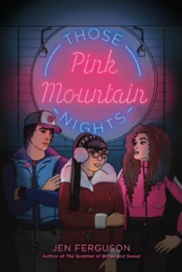
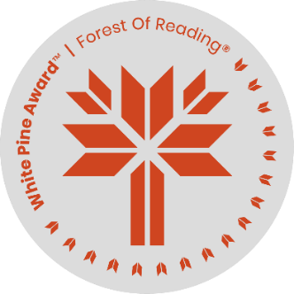
Those Pink Mountain Nights
Word Challenge

Name: ______________________________ Date: ______________________

Choose a word from Those Pink Mountain Nights to fit each category & give a brief explanation of why or how it fits.

 | Choose: | Responses
1 | A word that makes you happy
2 | A word that describes your best friend.
3 | A word you don’t know how to pronounce
4 | A word that reminds you of family
5 | A word you’d never seen before OR don’t know its meaning
6 | A word that makes you laugh
7 | A word that annoys you
8 | A word you love to say
9 | A word that would be a funny dog name
10 | A word that describes you

