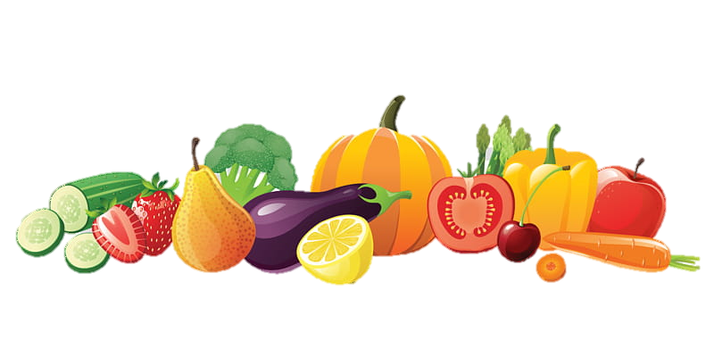.

**NAME:______________ DATE:___________________**

**ONLY THIS BEAUTIFUL MOMENT / BY: ABDI NAZEMIAN**

**FOOD GAME**



1. Let’s have research on Iranian food! Fill in the blanks with the correct name from the given list:

|  |  |  |  |
| --- | --- | --- | --- |
| Lavash | Kotlet | Kabob | Barbari |
| Yakhdar Behisht | Khorakeh | Tahdig | Kookoo Sabzi |
| Morgh | Khorishteh | Doogh | Faloodeh |

___________________________________________________

__________________________________________________

____________________________________________________

___________________________________________________

__________________________________________________

________________________________________________

_______________________________________________

Answer Key:

A.Yakhdar Behisht

B. Doogh

C. Kookoo Sabzi

D. Tahdig

E. Kotlet

F. Lavash

G. Barbari

H. Faloodeh

I. Khorishteh

J. Kabob

K. Morgh

L. Khorakeh

**________________________________**

**________________________________**



**________________________________**

**________________________________**



**________________________________**

___________________________________________________

__________________________________________________

____________________________________________________

___________________________________________________

__________________________________________________

________________________________________________

_______________________________________________

Answer Key:

A.Yakhdar Behisht

B. Doogh

C. Kookoo Sabzi

D. Tahdig

E. Kotlet

F. Lavash

G. Barbari

H. Faloodeh

I. Khorishteh

J. Kabob

K. Morgh

L. Khorakeh



**________________________________**

**________________________________**

**________________________________**



**________________________________**



**________________________________**

**________________________________**

**________________________________**



**ONLY THIS BEAUTIFUL MOMENT / BY: ABDI NAZIMIAN**

**ANSWER KEY**

A.Yakhdar Behisht

B. Doogh

C. Kookoo Sabzi

D. Tahdig

E. Kotlet

F. Lavash

G. Barbari

H. Faloodeh

I. Khorishteh

J. Kabob

K. Morgh

L. Khorakeh

**________________________________**