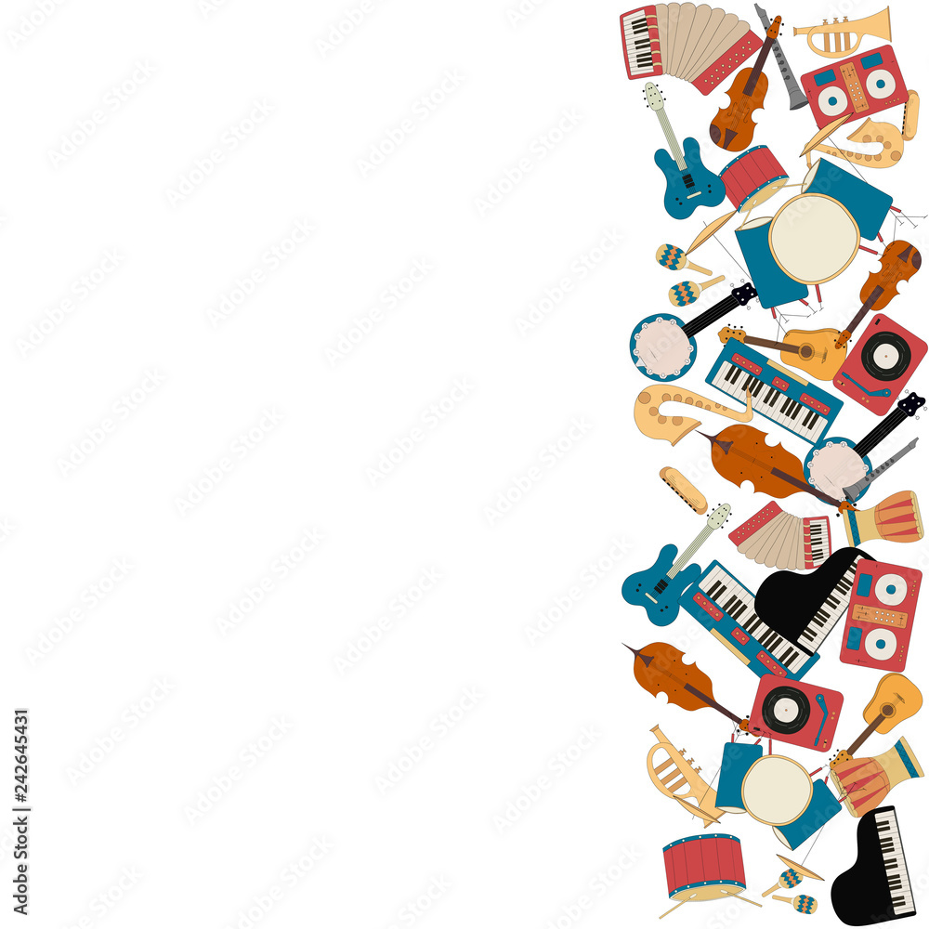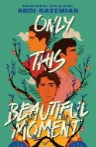

**Music and Singing**

**Answer Key**

**A**

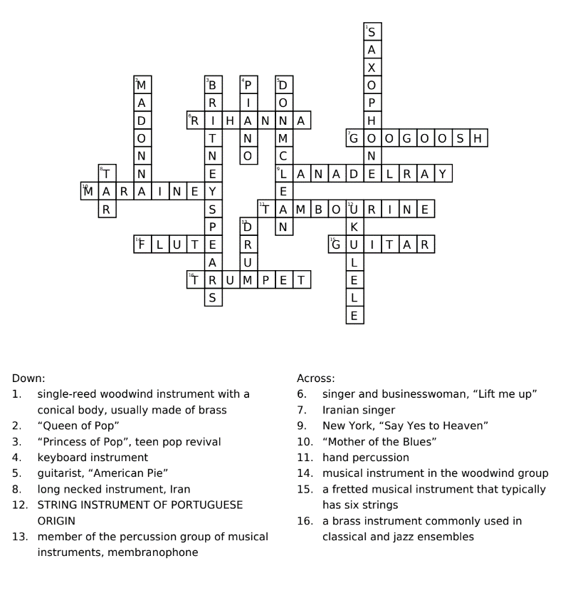

**CROSSWORD PUZZLE**

**ONLY THIS BEAUTIFUL MOMENT / BY: ABDI NAZIMIAN**