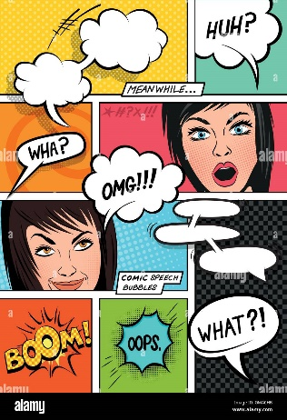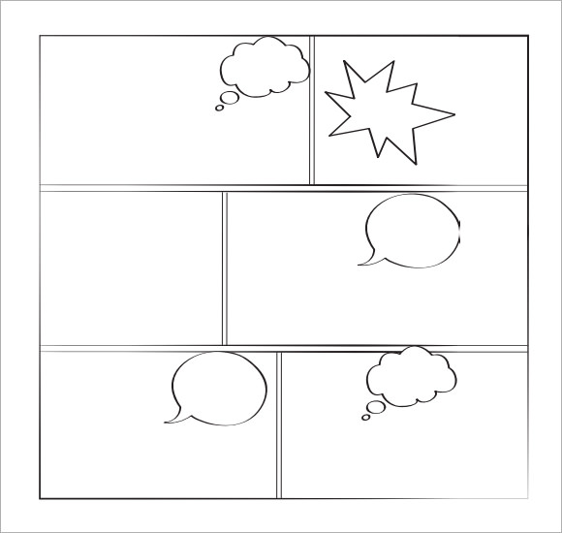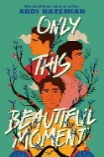

**Graphic Novel**

Draw your favourite characters and create a Comic strip with the dialogues based on their relationship!

**COMIC STRIP**

**Name:______________ Date:________________**

**ONLY THIS BEAUTIFUL MOMENT / BY: ABDI NAZEMIAN**