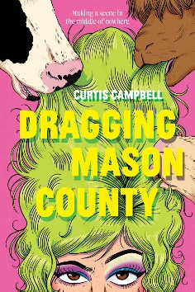
Dragging Mason County

Activity #1 – Discussion Questions

- Looking at the cover and book description of the novel, what were your expectations of the book before you began reading it? Did anything in the story surprise you?

- Peter finds himself in a sticky situation. Because of how a recording is edited, he appears to be making mean comments about Brison for no reason. Have you ever been in a situation where you saw content on social media that had been cut in such a way as to show a particular message? If so, when did you find out the broader context? When you view videos on social media, are you skeptical of what you are watching? Why or why not?

- Due to the video being posted to social media, Peter finds himself under scrutiny and tries to find a way to show he is not a hateful person. This is the reason behind Peter’s decision to produce the drag show. How much of your life would you say plays out on social media? Do you feel this is a good or bad thing?

- “Hurt people hurt people” is said a few times over the course of the novel. How much do you agree with this statement? Explain your reasoning using examples.

- In chapter 8 of the novel, there is a conversation between Lorne and Peter around intent vs delivery when speaking. Lorne tells Peter that while he might not intend to hurt Alan when he makes comments, how he ends up saying things can cause unintentional harm. How did you feel upon reading this passage? Did you agree with what Lorne said? Why or why not?

- In chapter 12, Peter mentions that he has been planning his escape from Mason County for a while, but remarks that Gerald has stayed in Mason County. Why do you think that Gerald ended up staying even though he also suffered teasing?

- Peter remarks several times throughout the novel that he feels like a secondary character to Alan’s protagonist. As the reader, we are seeing the events from Peter’s point of view. As you were reading did you agree with Peter’s assessment of his position? Why or why not?

- During the drag show, as Bailey is helping Peter do his makeup, Bailey remarks that, “I don’t know if this show will mean anything in the long run. Or my videos. Maybe we’re just pretty dummies in corsets. But it makes being born in the wrong place with the wrong people, feel bearable for a little while when you can show them how fucking good you are at being you.” How did you react to this statement? Do you agree with the sentiment? Explain your reasoning.

- The novel ends on a hopeful note, with the first meeting of the Mason Central chapter of the House of Rural Realness and Peter and Alan becoming friends again. What did you think of the ending? Did you like it? Why or why not?

