Red Maple Activity: Coding Activity
The Fort by Gordon Korman
Name: ______________________________

Play the game The Fort at https://scratch.mit.edu/projects/912606834
Try to find the missing fort without getting lost in the woods. But watch out for Luke and Jaeger who are driving around and trying to find you.

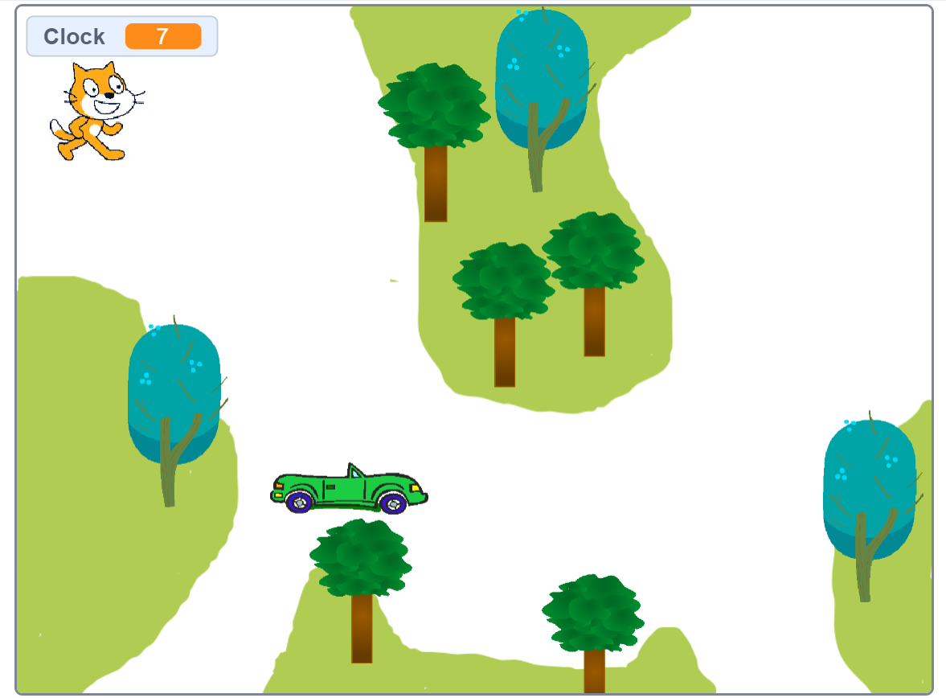

2. Create your own Scratch account by visiting https://scratch.mit.edu/. You can remix The Fort game and make it your own or start from “scratch” and make a new game.

