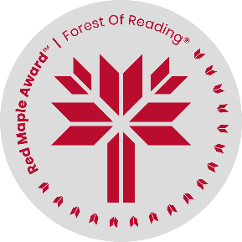
Red Maple Activity: Discussion Answers
The Fort by Gordon Korman
Name: ______________________________

1. Why does Ricky end up staying at Evan’s house?

2. What kind of fort do the boys find in the woods? What was it made for?

3. What are some of the Fort Rules the boys make for their fort? What rules would you make if you had your own fort?

4. What are some of the things the boys do to keep their fort a secret?

5. What do they find in the fort that they can pawn for money?

6. What are C. J.’s “death-defiers” and why does he do them so often?

7. What does Mitchell mean by “watering” Dr. Breckinridge’s plants? Why does he do it, and what does Dr. Breckinridge make Mitchell do when he finds out what Mitchell has been doing?

8. What does Luke see in Jaeger? What are some examples of when Luke is uncomfortable with Jaeger’s behaviour, and what does he do later to take a stand against him?

9. Why do you think the author wrote the story from different points of view?

10. What do the boys do at the end of the story? What are they surprised to find?

