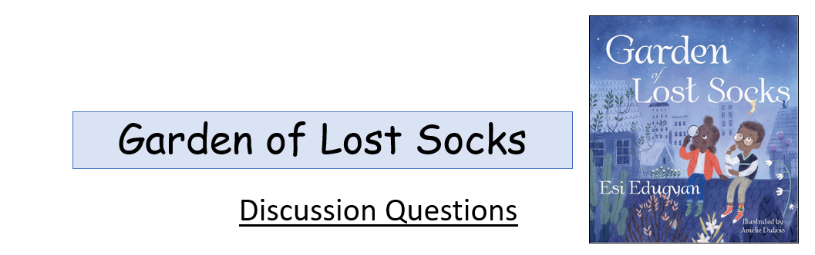

Before Reading

What is your favourite thing? What makes it so special?
Have you ever lost something special? Did you find it?
During Reading

Why were Max’s yellow, green and red socks with black stars on them his favourite?
What is an exquirologist? What is a journalist?
Which would you rather be?
After Reading

Where did Akosua and Max find the missing sock? What did they decide to do with it?
Who needed the sock most?
Would you give something you love to someone who needs it more than you?
What else Akosua and Max find?

