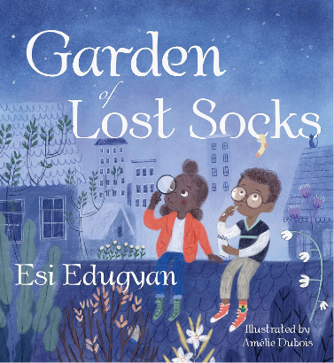 Name: ______________
In this story, Akosua helps her friend Max find his missing yellow, green, and red sock with black stars. Draw Max’s missing sock below. Then draw your favourite sock.
Draw Max’s missing yellow, green, and red sock with black stars here. | Draw your favourite sock here. Don’t forget to colour it in.

