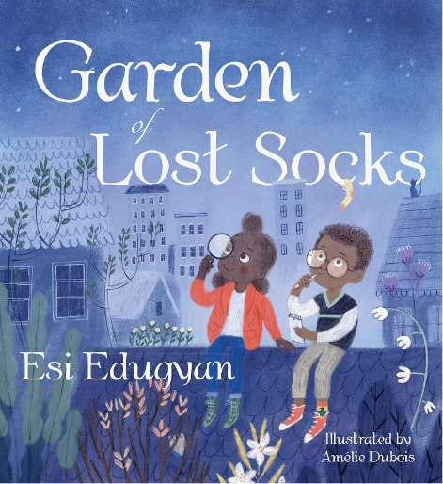
Garden of Lost Socks
Written by Esi Edugyan, Illustrated by Amelie Dubois

Reading Response – Finding a Lost Object
In this story, Akosua and Max search their neighbourhood for Max’s lost yellow, green, and red sock with black stars on it. Along the way, they explore their community and form a great friendship.

Beginning  At the beginning, Akosua wants to help Max find his lost sock. They look all over the neighbourhood.  I feel ___________________________ | End  At the end, Akosua and Max find they have learned a lot about their community. And they find Max’s sock in an unlikely place.  I feel ___________________________

