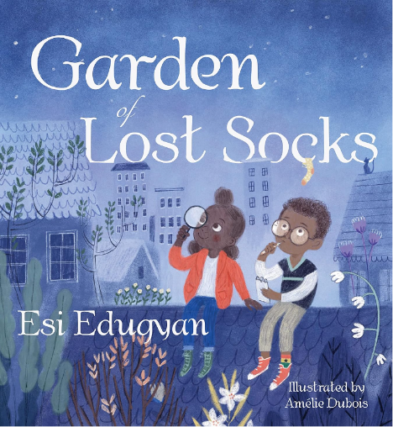
Garden of Lost Socks
Written by Esi Edugyan, Illustrated by Amelie Dubois

Reading Response - Discovery
In this story, Akosua and Max search their neighbourhood for Max’s lost yellow, green, and red sock with black stars on it. Along the way, they explore their community and form a great friendship.

Besides Max’s lost sock, what else did Akosua and Max find along the way:

- _________________________

- _________________________

- _________________________

- _________________________

- _________________________

