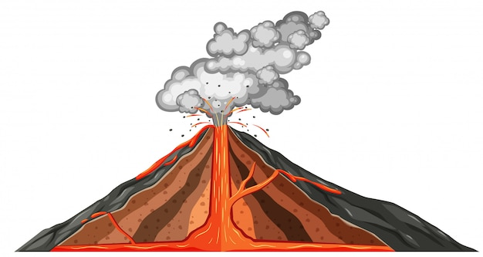

**MOUNTAIN OF FIRE**

STEM ACTIVITY

Make Your Own Volcano

Materials

* 6 cups flour
* 2 cups salt
* 4 tablespoons cooking oil
* warm water
* plastic pop bottle
* dishwashing detergent
* food coloring
* vinegar
* baking dish or another pan
* 2 tablespoons baking soda

Method

1. Start by making the cone of your [volcano](https://www.thoughtco.com/baking-soda-and-vinegar-chemical-volcano-604100) by mixing 6 cups flour, 2 cups salt, 4 tablespoons cooking oil, and 2 cups of water. The resulting [mixture](https://www.thoughtco.com/what-is-a-mixture-608185) should be smooth and firm (add more water if needed).
2. Stand the pop bottle in the baking pan and mold the dough around it to form a volcano shape. Be sure not to cover the hole or drop dough inside the bottle.
3. Fill the bottle most of the way full with warm water and a bit of red food coloring. (You can do this prior to sculpting the cone as long as you don't take so long that the water gets cold.)
4. Add 6 drops of detergent to the contents of the bottle. The detergent helps trap bubbles produced by the chemical reaction so you get better lava.
5. Add 2 tablespoons baking soda to the liquid in the bottle.
6. Slowly pour vinegar into the bottle, and then watch your volcano erupt!

The science behind this experiment

* The lava is the result of a **chemical reaction** between the baking soda and the vinegar.
* In this reaction, **carbon dioxide** gas is produced, which is also present in actual volcanoes
* As the carbon dioxide gas is produced, **pressure** builds up inside the bottle until gas erupts from the mouth of the volcano



Source:

Helmenstine, Anne Marie, Ph.D. "How to Make a Baking Soda Volcano." ThoughtCo, Apr. 5, 2023, thoughtco.com/baking-soda-volcano-science-fair-project-602202.