Name: ­­­­­­­­_________________________________

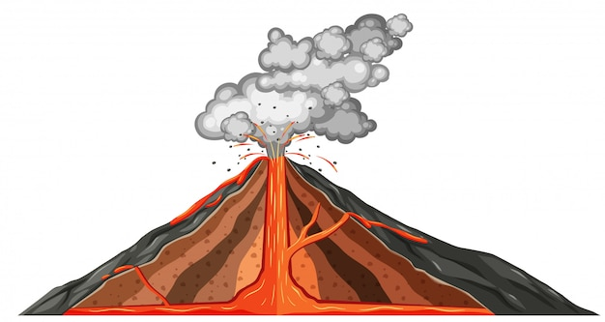

Date: _________________________________

**MOUNTAIN OF FIRE**

You have discovered a new volcano! In a paragraph below, give your volcano a name and location, describe it and create a myth or legend around it.

____________________________________________________________________________________________________________________________________________________________________________________________________________________________________________________________________________________________________________________________________________________________________________________________________________________________________________________________________________________

___________________________________________________________________________________________________________________________________________________________________________________________________________________________________________________________________________________________________________________________________________________________________________________________________________________________________________________________________________________________________________________________________________________________________________________________________________________________________________________________________________________________________________________________________________________________________________________________________________

Draw a picture that illustrates your volcano and its myth or legend.

