Name: ­­­­­­­­_________________________________

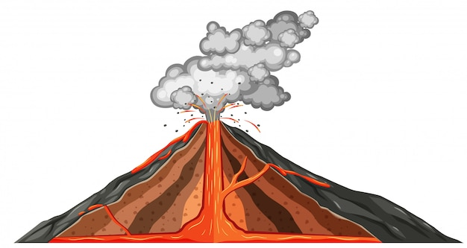

Date: _________________________________

**MOUNTAIN OF FIRE**

DEFINITIONS

Match the word to its definition.

* molten rock under the earth's surface: ______________________________________
* a type of volcano shaped like a giant oval plate: ___________________________
* a scientist who studies volcanoes: __________________________________________
* an instrument that measures gases emitted by volcanoes: _________________________
* a hole in the ground that shoots out hot water and vapour:__________________
* a mixture of ash, rocks, lava and gases:_____________________________________
* a large hollow formed when the magma chamber collapses: _______________
* a large cloud of ash: ______________________________________________________
* very hot, fluid rock that flows out of a volcano: ______________________________
* a volcano that is no longer active: _________________________________________
* a feature formed when gases mix with water in a crater: ____________________
* a round depression that emits ash, gases, rock and lava: ____________________

ACIDIC LAKE DORMANT MAGMA SHIELD

CALDERA GEYSER PLUME SPECTROMETER

CRATER LAVA PYROCLASTIC FLOW VOLCANOLOGIST

Answer Key

* molten rock under the earth's surface: **magma**
* a type of volcano shaped like a giant oval plate: **shield**
* a scientist who studies volcanoes: **volcanologist**
* an instrument that measures gases emitted by volcanoes: **spectrometer**
* a hole in the ground that shoots out hot water and vapour: **geyser**
* a mixture of ash, rocks, lava and gases: **pyroclastic flow**
* a large hollow formed when the magma chamber collapses: **caldera**
* a large cloud of ash: **plume**
* very hot, fluid rock that flows out of a volcano: **lava**
* a volcano that is no longer active: **dormant**
* a feature formed when gases mix with water in a crater: **acidic lake**
* a round depression that emits ash, gases, rock and lava: **crater**