Name: ­­­­­­­­_________________________________

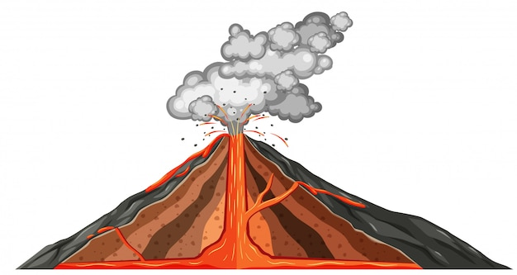

Date: _________________________________

**MOUNTAIN OF FIRE**

DISCUSSION QUESTIONS

1. How is a volcano formed?

______________________________________________________________________________

______________________________________________________________________________

______________________________________________________________________________

______________________________________________________________________________

2. Give an example of a myth or legend around volcanoes.

______________________________________________________________________________

______________________________________________________________________________

______________________________________________________________________________

______________________________________________________________________________

3. What volcano mentioned in the book do you find the most interesting? Why?

______________________________________________________________________________

______________________________________________________________________________

______________________________________________________________________________

______________________________________________________________________________

4. Describe how an eruption works.

______________________________________________________________________________

______________________________________________________________________________

______________________________________________________________________________

______________________________________________________________________________

5. Why were Maurice and Katia Krafft important?

______________________________________________________________________________

______________________________________________________________________________

______________________________________________________________________________

______________________________________________________________________________

6. What equipment is used to monitor volcanic activity?

______________________________________________________________________________

______________________________________________________________________________

______________________________________________________________________________

______________________________________________________________________________

7. What is the most fascinating thing you learned about volcanoes?

______________________________________________________________________________

______________________________________________________________________________

______________________________________________________________________________

______________________________________________________________________________



Answer Key

1. How is a volcano formed?

***A volcan is formed when a fracture in the earth's crust causes magma (molten rock) to spew onto the earth's surface, forming a crater.***

2. Give an example of a myth or legend around volcanoes.

***In Greco-Roman mythology, Vulcan (the god of fire and blacksmiths) lived and worked under a volcano.***

***The Maori say that the volcanoes Taranaki and Ruapehu fought over the love of a third volcano, Tongariro.***

***An Aztec legend tells the story of two lovers named Popocatepetl and Iztaccihuatl who died tragically and were turned into volcanoes. Then the Popocatepetl volcano erupts, he is expressing his love for Iztaccihuatl.***

***On Mount Bromo in Indonesia, pilgrims throw offerings into its crater and hold ceremonies to thank the gods for fertilizing the land.***

3. What volcano mentioned in the book do you find the most interesting? Why?

***Various responses***

4. Describe how an eruption works.

***Deep inside the earth, the temperature and pressure are so high that the rocks forming the earth's mantle slowly melt, forming magma. Since magma is in liquid form, it is lighter than the solid rock that surrounds it so it rises to the earth's crust and gathers in magma chambers. When there is a crack in the earth's crust, magma rises to the earth's surface, causing an eruption.***

5. Why were Maurice and Katia Krafft important?

***They were volcanologists who documented volcanic eruptions in photographs and films. They witnessed over 175 eruptions up close and climbed half of the active volcanoes that have erupted in recent human history. Their work (and death in a pyroclastic flow on Mount Unzen in Japan) has helped raise awareness of the dangers of volcanoes and prevented more tragedies.***

6. What equipment is used to monitor volcanic activity?

***Seismographs record vibrations of volcano-tectonic earthquakes. Spectrometers measure the concentrations of gases emitted by a volcano. Satellites detect heat and sulfur dioxide in and around active volcanoes. Drones are used to carry spectrometers.***

7. What is the most fascinating thing you learned about volcanoes?

***various responses***